**Portfolio management using AI**

* **J014: Aadityaharan Ganesh**
* **J034: Harshwardhan Palav**
* **J059: Saurabh Badkas**

**Objective:**

The aim of this project is Portfolio Management using Fundamental and Technical analysis. This project will use AI Algorithms to recommend the stocks that will provide the best Return on Investment (RoI), thus reducing Human effort for finding viable stocks. The stocks recommended will be the ones that form a part of NIFTY50, one of the two indices of Stock Markets in India, the other one being the BSE Sensex. With the help of Historical Data of NIFTY50, the machine will recommend Ten (10) best stocks to invest in, while considering various Fundamental and Technical characteristics.

**Requirements:**

The requirements of this project are as follows:

* Historical Data of NIFTY50.
* Python 3 and above
* Machine Learning algorithms

**Approach:**

Firstly, the historical data for all NIFTY50 stocks for a time range of 1 year will be collected. ETL process and Data cleaning process will be performed to prepare the data for the various Machine Learning Algorithms that will be applied on it. After Data Cleaning, Machine Learning Algorithms will be applied by the help of which one can determine the top 10 stocks in terms of Return of Investments over different intervals of time (1 week,1 month or 1 year). Finally, the code will be tested to ensure functionality.

**Block Diagram:**

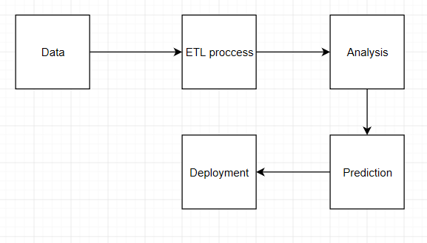

**Flowchart:**

